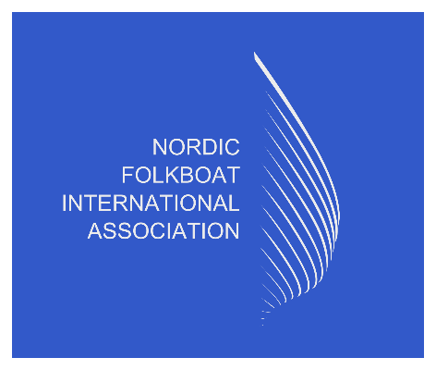

Annual General Meeting 2026, Nordic Folkboat International Association.
Venue: Seglermesse
Priwallpromenade 18
Travemünde
23570 Lübeck
Date: Wednesday, 22nd July 2026, 1900 CEST
1: Apologies for absence.
None received
2: Roll call for accredited NFIA representatives.
SW – Chairman, LM – Technical, GM – Vice Chair, SO – Secretary & Treasurer, KM – UK, MM – DEN (online), HW - SWE
3: Minutes AGM 2025.
Agreed and signed off
4: Reports from the chairman, technical chairman, treasurer and secretary.
All reports presented to the attendees.
Key areas of discussion:
Gold Cup fleet numbers, whilst declining it was agreed to host an International meeting to discuss in more detail how to attract new members and member interaction, and to analyse whether this is limited to the Gold Cup and boat ownership is static or increased - NFIA to organize International meeting
Secretary reported we are now in a position to cease plastic buttons for sails, and the NFIA board to look at alternatives at next meeting.

6: Request to release the Board members from their duties in the preceding year
Agreed
7: Suggestions from the members and future event updates
Under the discussion of upcoming events, we still require 2028 Gold Cup confirmation with Sweden consideration of Marstrand, which the local association are still awaiting a response and have also received interest from Malmo.
2029, awaiting formal documents from the Netherlands to host the event.
It was noted that Hanko, Finland 2026 is progressing well, but advised for those seeking accommodation to book early as there is a non-sailing event taking place which will put a strain on bookings.
8: Elections of board members.
Agreed with all International members to support nominations for the replacement of TC, S & T. It was suggested that the Secretary and Treasurer role be possibly split as a significant time requirement to host both roles. It was also raised to potentially have a Social Media manager.
- Chairman - Steffi Westerlund (2025 Appointment 3-year term)
- Vice Chairman – Gero Martens (2026 Appointment 3-year term)
- Technical Chairman – Lennart Magnusson term extended in 2024 (2027) Replacement required
- Secretary and Treasurer – Simon Osgood term extended in 2024 (2027), Replacement required

9: Any other business.
MS – US, openly asked for support or feedback for the San Francisco International event. This could be potentially hosted in 2026/27. Please can all international fleets canvass support and feedback to Mark as soon as possible. It was agreed that this is a great event and one we should all try and support
Final point on events, the Sessan Cup is due in 2027, and we still require a host.
Meeting ended at 8:15pm local time (note: delay to meeting due to technical challenges)

