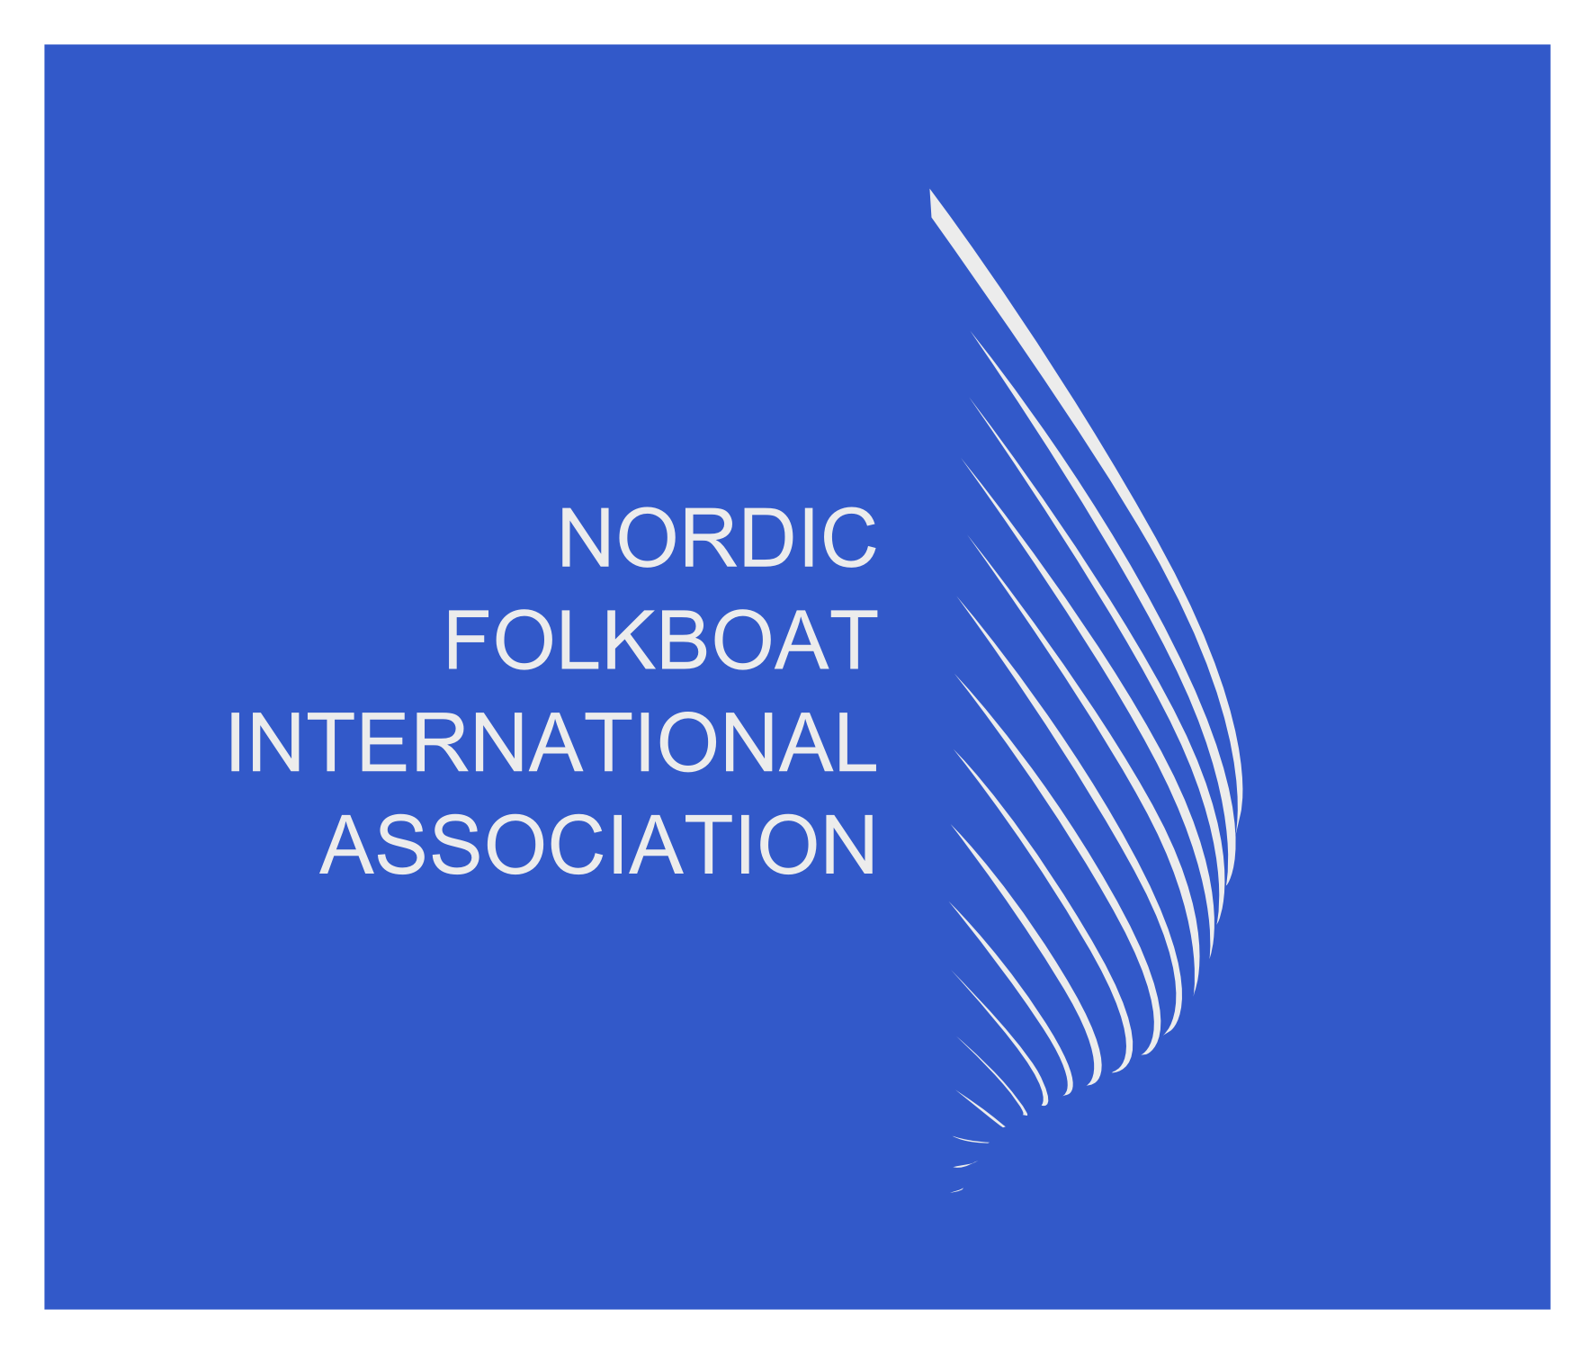

Nordic Folkboat International Association (NFIA)

AGM Minutes

To: All NFIA members
From: NFIA Board – Per Buch, Lennart Magnusson, Steffi Westerlund, Simon Osgood
Attendees: NFIA Board, UK, Germany, Netherlands, Sweden, Finland, Estonia National Associations

- Chairman introduction and report – PB
- Opening reports distributed and agreed for Secretary, Treasurer and Technical
- Technical Chairman gave an overview and vision for supporting the class rules at a local level to gain a proactive method of approach to measuring- LM
- All attendees agreed to contuning support technically to ensure we continue to be a strong one-design class.
- UK fleet raised the point of spinnaker sizes recognised and published by NFIA. It was agreed that LM would form a working group for those countires who use spinnakers locally and feedback to NFIA (EST, UK, FIN and NED) – LM
- Class rules updates were sign off unanimsouly
- Board terms presented and unanimously signed off including extension full terms for secretary, treasurer (SO) and technical (LM)
- AOB included the Netherlands hosting the 2025 Sessan Cup, more updates to follow on the hosting and dates
- AOB a new Turkey company is building a wooden folkboat. Their Instagram story can be found at folkboat_anatolia
- Next 3 years Gold Cup venues as follows: 2025 Hellerup Sejlklub in Copenhagen 2-6 July. 2026 Travemunde Germany, 2027 Hanko Finland

