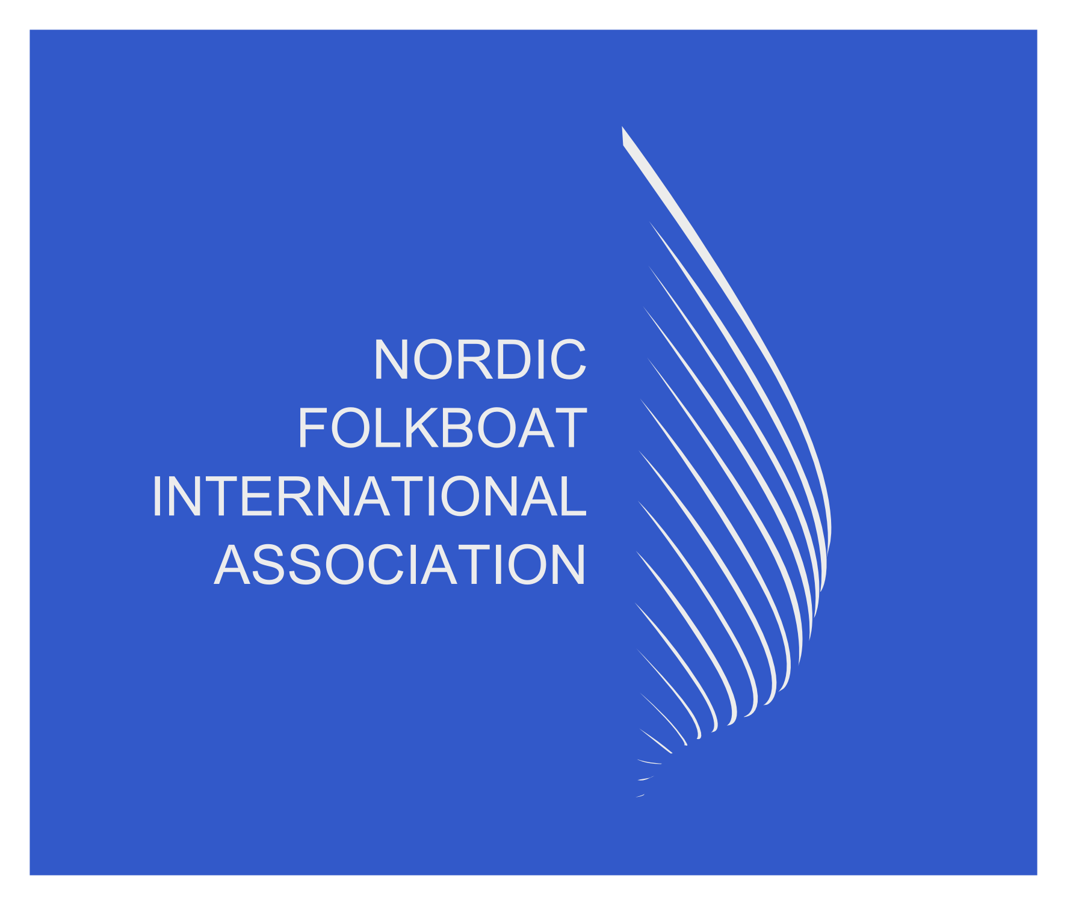

Nordic Folkboat International Association (NFIA)

AGM Statement Secretary and Tresurer 2023.

To: All NFIA members
From: NFIA Secretary and Treasurer
Secretary Commentary

Event participation remains strong in most territories and the reinvention of the Sessan Cup adds back another event to the calendar, as recently hosted in 2022, and prior to this not hosted since 2014. In 2022 our analysis shows over 250 boats in total competed in National Championships, Gold Cup, Sessan Cup and Rolling home, spread over 7 countries. This supports the theory that the Folkboat is still an extremely popular one design keelboat, celebrating 81 years young.

We have pushed our social media presence especially on Instagram, with 164 followers and 50 posts since January 2023. We will continue to put out as much relevant content as possible.

Most popular content interaction has been Championship features and Boat shows of which the Folkboat was represented in Germany and Sweden this year. Please do send or tag NFIA_NORDIC_FOLKBOAT in anything relevant on Instagram. This has been successfully done by the Swedish and the Estonian fleets.

Any press articles on racing or cruising we would welcome sent to secretary@folkboat.com for our website. Our website has been fully functional since January with content posted at least twice a month.

A final call to our members is we would like to have any cruising articles or voyages undertaken of signifance as a feature for the website.

In summary we are still in a strong position as a class, from all the indicators we can see from a secretary level of interaction.

Tresurer Commentary

Please find the NFIA financial details for the period June 2022 to end of May 2023.

Overall the NFIA finances are in good shape, exceptional one off costs this year was the website and technical upgrades to migrate all emails to Microsoft teams and all board members access to the full suite of Microsoft functanlity, including TEAMS.

The aim was to allow seemless continuity from a technical perspective and future proof our organisation when looking at technical dependancies.

A quickview of our revenue indicates a decline in sail buttons (12%) YOY, which is our number one revenue driver. There was also a signifant drop off in the demand for plans (39%) YOY. The former commentary could be attributed to sailmakers holding signifant sail button stock from last year and we envisage this to recover to the 2021 levels over the next 12 months. NFIA issued mast plaques continue to be strong as is the demand for alluminium.

A final point of note is we have not had to issue any new boat plaques this year.

NFIA continues to support the Gold Cup and young entrants for this event. Two burseraries were given last year and another two will be done this year, so this continues to be a popular and effective way to attract young sailors to our fleet. It is imporatnt to note we had no costs in 2021 for the Gold Cup due to COVID, which has an impact on ‘21 versus ‘22 cost.

We continue to hold sail button stock and mast label stock which should cover the next 3 years. Our aim would be to use a more sustainable button material when we run out of the sail buttons which are made of plastic.

As an organisation we continue to remain fiscally responsible and cost concious. Our postage, bank charges and travel costs continue to remain zero through changes implimented in the past 18 months.

Simon Osgood 25.07.23

