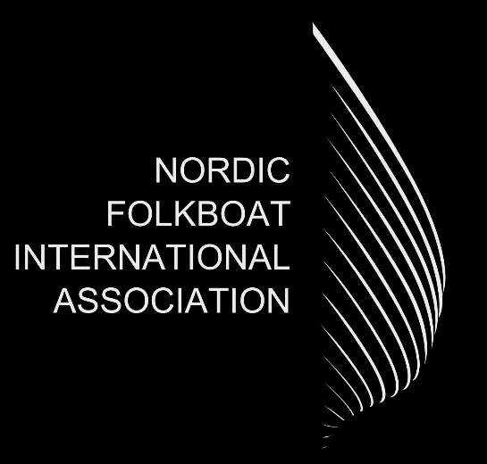
2023 NFIA AGM, Monday 31st July 19:30 EST, Kalev clubhouse in Tallinn and Teams.

Minutes for the Annual General Meeting

Chairman Per Buch opened the meeting at 19.30
- Apologies for absence.

There were no apologies

- Roll call for accredited NFIA representatives.

National associations were represented by

UK, David Fox, 1 vote
Germany, Jürgen Breitenbach, 5 votes
Sweden, Rolf Uppström, 3 votes
Finland, Ilppo Kivivuori, 2 votes
Denmark, John Wulff, 4 votes
Estonia, Mikk Köösel, 1 vote

Board members present at meeting:
Per Buch, Lennart Magnusson, Stefan Westerlund, Simon Osgood

Other participants
Tõnis Piirsalu, Nicky Henderson

- Approval of the minutes from the AGM 2022.

Minutes were approved.

- Reports from the chairman, technical chairman, treasurer, and secretary.
Per Buch, Lennart Magnussen and Simon Osgood presented their reports.

TC report raised issues to be discussed when preparing the new class rule 2025-28. National associations were asked to discuss and present their views by november in following issues:

- placement of crew members during races
- allowed electronic devices.

5.0 Vote about using spinnakers during NFIA recognized international events (Gold Cup and Sessan Cup).
No: 13 votes (UK, Germany, Sweden, and Denmark)
Yes: 4 votes (Finland, Estonia, and Netherlands)

- Request to release the board members from their duties in the preceding year.

Board members were released.

- Approval of the amendments and clarifications for the Class Rules 2021-2024.

The published amendments were accepted.

- Suggestions from the members (must be in the hands of the Secretary 6 weeks before the AGM).

There were none.

9.0 Board member election

None this year.

10.0 AOB

John Wulff (DK) raised the issue of professional sailors and its effect on class. NA´s were asked to discuss the issue and present their views by November in connection with other class rule issues. International meeting on MS Teams will take place November 8 at 19.00 CET. Invites will follow.

